WildTangent Standardized Content Library (.lib) for Keres

WTGameLib v1.0

1 WTGameLib 1
1.1 Overview 1
1.2 Provided .lib’s 2
1.3 Provided API 2
1.4 Setting up a SKU for development purposes 3
1.5 Registry Layout 4

WTGameLib

Overview
This library will provide an easy and consistent method of obtaining late bound data provided by the new Packaging System “Keres”. Data the game might want such as a Boolean “LaunchInFullscreen” can be set at packaging time for the content to consume. This allows us the ability to tweak various aspects of the content without having to recompile the game, saving valuable testing time. It also allows us to setup general contractual data specific to distribution partners, such as whether to check for game updates, or show upsells, or the upsell url, etc… again without having to recompile the game.

Provided .lib’s
Libraries will be provided for Debug/Release modes, char/mcbs/unicode, single/multithreaded, and support VC6/VC7 lib linking. All methods which use a character array will attempt to protect against buffer overrun.

Provided API
Method:
void CRuntimeAttribute::GetSKU (TCHAR* ReturnValue, int ReturnValueBufferSize );
Summary:
Returns a string representation of the product’s SKU Number. This is provided for the sole possibility that another product we make (such as ecomm or wildboards) may need it. It is known internally within the WTGameLib and thus not needed for use of this .lib.

Method:
void CRuntimeAttribute::GetString(const TCHAR* Name, _TCHAR* ReturnValue, int ReturnValueBufferSize );
Summary:
Returns a string representation of the value of a given Name. If the Variable cannot be found, an exception will be thrown.

Method:
int CRuntimeAttribute::GetInt(const TCHAR* Name );
Summary:
Returns an int representation of the value of a given Name. If the Variable cannot be found, an exception will be thrown.

Method:
float CRuntimeAttribute::GetFloat(const TCHAR* Name );
Summary:
Returns a float representation of the value of a given Name. If the Variable cannot be found, an exception will be thrown.

Method:
bool CRuntimeAttribute::GetBool(const TCHAR* Name );
Summary:
Returns a boolean representation of the value of a given Name. If the Variable cannot be found, an exception will be thrown.

Setting up a SKU for development purposes
When developing a game using the WTGameLib it is handy to setup the data your game needs in an easy manner. To help facilitate this, a script named TESTDEV0_Setup.wsf is provided in the scripts directory. Double click it, to run it on your machine.

This script will setup the development SKU (named TESTDEV0) at HKLM\Software\WildTangent\InstalledSKUs\TESTDEV0 and will put in common variables one might expect, when the content is actually packaged.

You can add your own data to the registry as well. The WTGameLib always reads type REG_SZ, also known as strings. If you have to specify an int, float, or bool, create a regkey of type REG_SZ and type it in as a string. The WTGameLib will convert the string to whatever type you actually want automatically for you when you call the appropriate GetBool, GetInt, GetFloat functions.

NOTE:
ExeName, LaunchExeName, InstallDirectory:
When using the TESTDEV0 SKU, the return value from GetString for these variables is retrieved by examining the currently running application instead of retrieving the registry information. This allows the content to act as if it had been installed as a properly formed package.

IMPORTANT NOTE:
If the TESTDEV0 SKU exists in your registry and you run an app which did not get packaged properly (i.e. contains no SKU data in the registry) that app will default to reading this data. This shouldn’t happen on end users machines as the TESTDEV0 SKU will not exist, however it is worth watching out for if you’re confused as to why application A is pulling in application B’s data.

The potential for this to happen would occur if TESTDEV0 exists and a valid SKU was moved from one folder to another after installation or if the game was installed with a non QA-approved wrapper (installer).

Registry Layout
The registry location for SKU’s will be:
HKEY_LOCAL_MACHINE\SOFTWARE\WildTangent\InstalledSKUs

The WTGameLib will require that a SKU’s key contain the following string’s:
ExeName
The name of the executable. This is known at packaging time already.

For development purposes, adding a SKU named “TESTDEV0” will match the application being executed with stored data in the registry if the GameLib fails to find the actual SKU data. A script has been added to the delivery to setup a TESTDEV0 SKU, in a way consistent with what one might expect from Keres.

InstallDirectory
The directory the user chose to install the executable to. This may be specified in a GUI installer or may be set automatically by a silent installer… it just has to be there in the end.

The registry for a well formed package should look similar to the following:

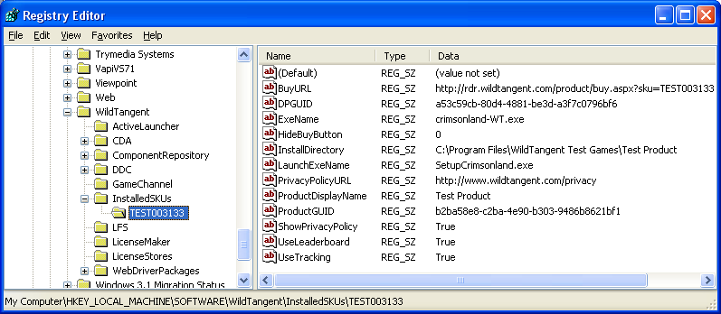

In order for a SKU to get data about itself from the registry, it needs to know what its SKU number is. The most intelligent way of doing this is to have the WTGameLib library parse all SKU’s in the registry and look for the InstallDirectory string and the ExeName string. If the executing code’s name matches the ExeName stored in the registry, and the install directory is the same, then we can be assured that the data in that key is for the code which is running. Whereas, if we just looked at the InstallDirectory string, we might run into issues where two products share the same folder, and likewise, if we just look at the ExeName, we might run into a scenario where “Blasterball II for HP” is reading the settings for “Blasterball II for WildGames” because the user chose to install both on their machine.

